

**Technical Report**

Navjot Singh Virk, Student Number: X13112406, Email: virksaabnavjot@gmail.com

Software Development Stream 4th Year

BSc. Honors in Computing, **National College of Ireland** *(2016-2017)*

**Available on**

**Project Name:** MeetingRoom Pro

Github: <https://github.com/Virksaabnavjot/MeetingRoom-Pro>

Website: <http://roomassistant.navsingh.org.uk>

Documentation: [Github Repository here](https://github.com/Virksaabnavjot/RoomAssistant-Documentation-Repo)

Table of Contents

Executive Summary 4

1 Introduction 5

1.1 Background 5

1.2 Aims 5

1.3 Technologies 5

1.4 Structure 5

2 System 6

2.1 Requirements 6

2.1.1 Functional requirements 6

2.1.2 Requirement 1: Easy to Use GUI 7

2.1.3 Requirement 2: List and Find(Search) 8

2.1.4 Requirement 3: Map / Navigation 9

2.1.5 Requirement 4: Geo Location Notifications 10

2.1.6 Requirement 5: User Registration 11

2.1.7 Requirement 6: Booking System 11

2.1.8 Requirement 7: Photo Gallery 12

2.1.9 Requirement 8: Photo Upload 13

2.1.10 Requirement 9: Review 14

2.1.11 Requirement 10: My Meetings 14

2.1.12 Requirement 11: Call 15

2.2 Non-Functional Requirements 16

2.3 Data requirements 18

2.4 User requirements 18

2.5 Environmental requirements 18

2.6 Usability requirements 18

2.7 Design and Architecture 18

2.8 Implementation 18

2.9 Graphical User Interface (GUI) Layout 18

2.10 Testing 19

2.11 Customer testing 19

2.12 Evaluation 19

3 Conclusions 21

4 Further development or research 22

5 References 23

6 Appendix 24

6.1 Project Proposal 24

6.1.1 Objective 24

6.1.2 Background 25

6.1.3 Technical Approach 25

6.1.4 Special resources required 28

6.1.5 Gantt Chart 28

6.1.6 Technical Details 29

6.1.7 Evaluation 29

6.1.8 Proposed Supervisor 30

6.2 Project Plan 31

6.3 Requirements Specifications 32

6.3.1 Introduction 32

6.3.2 User Requirements Definition 34

6.3.3 Design Thinking for User Requirements Definition 35

6.3.4 Requirements Specification 35

6.3.5 Interface requirements 45

6.3.6 System Architecture 49

6.3.7 System Evolution 50

6.4 Monthly Journals 51

6.4.1 Reflective Journal 1 51

6.4.2 Reflective Journal 2 53

6.4.3 Reflective Journal 3 (November) 55

# Executive Summary

With MeetingRoom Pro I have looked to develop a user friendly IOS application to solve the problem of finding meeting rooms in large buildings. I aimed to address a problem I had encountered personally in the past during my work placement and other people i.e. finding meeting rooms is complex and inconvenient. The application is designed in way that it can be easily tailored for the use of any organization, with change in data provided through API i.e. building and meeting room coordinates. The will be available to for iPhones and iPads. The application will help people find rooms with ease and navigate through map with their location shown on the map and also have the option to book the rooms straight from the app. App client will be developed using Swift 3 and Xcode Ide.

# Introduction

## Background

During my work placement at SAP SE, I was engaged in several meeting from my induction to my farewell meeting, there were more than 50 meetings, from team meetings to global team meetings, intern meetings and HR meetings, to employee farewell meetings which I was part of in the course of 7 months of internship.

And number one issue was finding the meeting room due to big size of the buildings, if the meeting room was close enough to my desk, it was easy enough to find the meeting room but the problem used to arise when the meeting rooms were on different floors, even different wing of the same floor and the problem was big when trying to find a meeting room on another building and some fancy names to the meeting rooms didn’t make much sense at all and the icing on the top if you are short on time i.e. have consecutive meetings to attend and the only solution available was to ask you collages if they didn’t know run towards the reception and they would show you a floor plan which sometimes didn’t made sense and overall experience in finding meeting rooms was not up to the standards to which it could be achieved.

I started some research and found other employees were facing the same issues and were just limited to using meeting rooms near their offices due the hassle of finding meeting rooms, after talking to people the user research findings were not just the interns who felt this pain, some of the very senior employees which were there for many years didn’t know where some of the meeting rooms were and since SAP is multinational company, there were always employees from different location which travelled to attend meetings and had very hard time finding the meeting room and first have to go to facilities department and the facilities member would manually assist wherever this process can be automated i.e. a simple to use application could solve this problem.

Hence, there is were the idea for the application is developed from but it is not just limited to corporate world the application can be put to use in universities and college with minor changes.

## Aims

The aim is to develop an easy to use mobile application that help people find meeting rooms with ease in a big building and provide some other useful functionality like:

Map and Navigation – The user will select a meeting room and the application shall show be able to show a detailed map with navigation to the room.

Room Booking – When a user wants to book a room instead of finding they can do so as well or both book and navigate.

Proximity Alerts - When a customer device comes within a radius of the meeting room in which they have a meeting in soon they will receive a notification saying you are this close to the meeting room and they can start the navigation.

I will describe the rest of the functionality in the Systems Requirements section.

The application has the potentially to be adapted internationally because of its scalability. There is very high possibility that business organizations, universities and colleges will buy the application for use for their staff and students. Essentially the app can become a valuable resource to anyone and any organization and provide extraordinary results for people using it.

## Technologies



I decided on Swift 3 as my primary coding language for my IOS application development. I came across Swift as a language during my internship and have a beginner level understanding of the language and would like to advance my understanding of the language through this project. Swift is a fairly new language and is open source and moving towards cross-platform which will open new possibilities in the future. I find Swift to be a fast and versatile language.

Below are some other features of Swift that provided me with motivation to use it for my final year project.

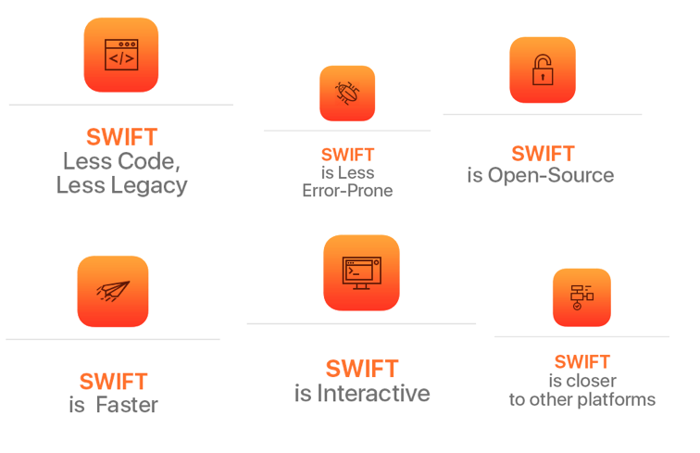

Image Source:http://mlsdev.com/en/blog/51-7-advantages-of-using-swift-over-objective-c



I have decided to use JavaScript on the backend to create XSJS web service/API. XSJS (SAP Hana XS JavaScript) is an application programming language in JavaScript. It can be used to exposes data stored in database tables or views to client side. Additionally, we can also implement any business logic.



In Swift, I have experienced its not very easy to parse JSON, So, I have decided to use an open source Swift library SwiftyJSON to help me with parsing JSON data that the application client will receive from web service.



I will be using Xcode IDE for the development of the application client as it’s the default editor for developing IOS Swift apps.



I have decided to use SAP Hana for two reasons as RDBMS –

* It allows to store Geo-spatial data – Which I will need to store buildings and meeting rooms coordinates.
* I have some understanding of it as I used it during my internship and would like to learn more about it as I already have a lot of working knowledge of MySQL so I wanted to use a little different database system so I can learn new things.

I will be using the trail version of SAP Hana (HCP – Hana Cloud Platform)

Drawback: In trail version the database needs to be restarted every 12 hours to keep it available at all times.



For source control I am using Github. As, it allows me to keep my code available anywhere not worrying about losing it and even go back in time code that that time.

Other technologies that might be used for this project:

HTML and CSS for the gallery feature in the app. And I will be open to more technologies if needed during the development of the project.

## Structure

The structure of this report allows the reader to receive a general overview of the project with the first section. Here the background, aims, and technologies will be detailed, allowing the reader to better understand the direction the project was to take.

The second section details the system and the requirements. Here will list the necessities that must be implemented as to allow the software to be functional and successful.

This section will also detail the design and architecture of the system, as well as describing the implementation and the use of the graphical user interface. Finally, this section will also touch on testing of the software and how it was evaluated.

The third section provides any concluding thoughts I had regarding the project and its development.

With the fourth section I have detailed any potential development plans for the project, describing the areas in which it can grow post submission.

The fifth section details any references, listing the resources used throughout the project development.

The sixth section contains the appendices, containing the original project proposal, project plan, requirement specification, and the monthly journals.

# System

## Requirements

### Functional requirements

Use Case Diagram

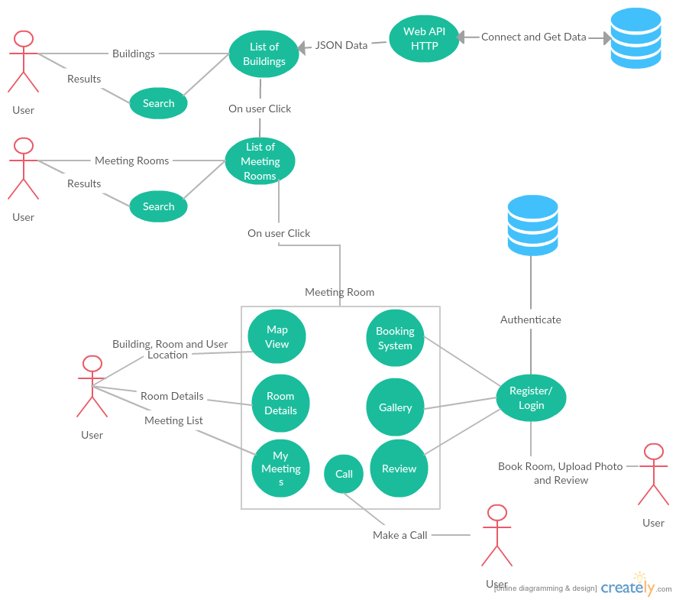

The above Use Case Diagram provides an overview of all functional requirements of this project.

### Requirement 1: Easy to Use GUI

#### User Story

As a user I want to have an easy to use interface so as I can navigate through the app easily with little time needed to be spent learning how to use the app

**Use Case Diagram**

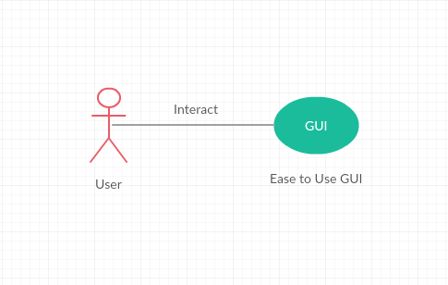

#### Description & Priority

The system shall have an easy to use graphical user interface. Navigation will be possible through the touch screen functionality of the IOS device. The design shall also be responsive so as to support different screen sizes of iPhones and iPads.

*Essential and High Priority Requirement*.

#### Requirement Activation

This requirement will be activated upon starting of the application.

#### Technical Issues

GUI Need internet connection to get data from API which will be shown in the application, slow internet connection can affect performance of the GUI.

#### Risks

Provision must be taking that not all users have a good understanding of technology and the use of mobile platforms. If the GUI is to become too complex, some users may not use the application. This requirement is at the core to the success of the system.

#### Dependencies on other requirements

N/A

### Requirement 2: List and Find(Search)

#### User Story

As a user I want to be able to find buildings and meeting rooms with ease. Like a clickable list of buildings which then browse to list of meeting rooms also search and I can select a meeting room and find it or use other features like room booking, gallery upload etc.

#### Description & Priority

The system shall allow to search and also provide list of available buildings and meeting rooms.

*High Priority*

#### Requirement Activation

The requirement to list buildings and meeting rooms will be activated upon starting of the application and search is activated when user enters in search bar.

#### Technical Issues

N/A

#### Risks

This requirement is at the core to the success of the system as most of the requirements hereafter have a dependency on this one.

#### Dependencies on other requirements

This requirement has a dependency on requirement 1 - Easy to use GUI.

### Requirement 3: Map / Navigation

#### User Story

As a user I want to be able to view the building highlighted on the map. Also the meeting room I am looking for along with my current location and some information about the building and room like floor number.

#### Description & Priority

The system shall have an expandable map with current location of the user and building drawn on the map.

*Optional: The application should leverage some sensors or beacons implemented in the building for effective indoor navigation as GPS may not provide accurate location indoors.*

#### Requirement Activation

The requirement will be activated when the user selects a meeting room from a list of rooms.

#### Technical Issues

N/A

#### Risks

May face some issues with current location of the user while indoors as GPS is not designed for indoors and this may affect the accuracy of the location slightly.

#### Dependencies on other requirements

N/A

### Requirement 4: Geo Location Notifications

#### User Story

As a user I want to have notifications automatically sent to me when within a certain radius of the building or the meeting room so I am notified that the destination is close enough.

#### Description & Priority

The system shall have functionality that when a user’s smart phone comes within a certain radius of the meeting room a notification will be sent to remind them with approx. distance to the destination i.e. *"Hey,… you are “approx. distance” from your destination ….".* Functionality to unsubscribe to this service should also be provided. *High priority*.

#### Requirement Activation

This requirement will only be activated if a user brings their mobile device which they have the app installed on within a certain radius of the building/meeting room. This distance will be tweaked at the system/ user testing stage of project. This service should also only occur once while finding a meeting room as if a client user was moving in and out of the geographical perimeter they will not receive multiple notifications. As stated above functionality to unsubscribe to this service should also be provided.

#### Technical Issues

N/A

#### Risks

N/A

#### Dependencies on other requirements

N/A

### Requirement 5: User Registration

#### User Story

As a user I shall be able to easily register within seconds to use the advanced features like posting reviews and uploading photos.

#### Description & Priority

The system shall provide a standard registration and login. The requirements like booking and reviewing require registration in order to allow users to use these features.

*High Priority*

#### Requirement Activation

The requirement is activated when user wishes to book, review meeting room and upload photos of the meeting room.

#### Technical Issues

N/A

#### Risks

N/A

#### Dependencies on other requirements

N/A

### Requirement 6: Booking System

#### User Story

As a user I want to be able to book meeting rooms through my smartphone so as I can book meeting rooms easily from anywhere.

#### Description & Priority

Functionality for users to book meeting room once selected a meeting room. This feature shall have its own page and be easy to use i.e. drop down lists to choose data and time of booking and the user shall be able to see the booked meeting rooms.

*High priority*

#### Requirement Activation

This requirement will be activated if the client user wishes to book a meeting room.

#### Technical Issues

N/A

#### Risks

This requirement is very important as some of the requirements hereafter have a dependency on this one.

#### Dependencies on other requirements

This requirement has a dependency on requirement 1 - Easy to use GUI and Requirement 2 – List and Search

### Requirement 7: Photo Gallery

#### User Story

As a user I shall be able to see some photos of the meeting room showing the equipment available and size of room straight from the app.

#### Description & Priority

The system shall have a photo gallery with multiple photos of the room.

*Medium Priority*

#### Requirement Activation

The requirement will be activated when a user selects a meeting room from the list.

#### Technical Issues

N/A

#### Risks

N/A

#### Dependencies on other requirements

N/A

### Requirement 8: Photo Upload

#### User Story

As a user I shall be able to upload some picture from my phone gallery or camera if some pictures are missing in the Gallery.

#### Description & Priority

The system shall allow all registered users to upload images of the rooms to the photo gallery. And also allows users with admins and moderator accounts to delete the low quality images straight from the app.

*High Priority*

#### Requirement Activation

The requirement will be activated when user wishes to upload an image.

#### Technical Issues

N/A

#### Risks

Some users may try to spam or misuse this feature.

#### Dependencies on other requirements

The requirement has a dependency on requirement 7: Photo Gallery

### Requirement 9: Review

#### User Story

As a user I would like to see some reviews available about the room and its equipment and also like the functionality to review it myself.

#### Description & Priority

The system shall allow the registered users to review meeting rooms based on different parameters like – functionality and quality of available equipment, if the room temperature was good and so on as user feedback will help improve the quality of the meeting rooms and the meeting rooms getting low ratings can be improved and get more attention from IT and Facilities department.

Medium Priority

#### Requirement Activation

The requirement will be activated when the user wishes to review meeting room.

#### Technical Issues

N/A

#### Risks

N/A

#### Dependencies on other requirements

N/A

### Requirement 10: My Meetings

(Calendar event / Reminder of booked meeting feature)

#### User Story

As a user I would like to see all my meetings and simply start the map navigation.

#### Description & Priority

The system shall provide a list of meetings booked for the user and the user will receive a reminder notification. The system should be able write and read meetings to and from the device calendar.

#### Requirement Activation

The requirement will be activated when the user has some meetings in their calendar.

Medium to Low Priority

#### Technical Issues

N/A

#### Risks

N/A

#### Dependencies on other requirements

The requirement has dependency on requirement 6: Booking System

### Requirement 11: Call

#### User Story

As a user if I am in a meeting and some equipment is not working I should be able to contact the key contacts for the room that can fix the problem for me i.e. make a quick call from the app.

#### Description & Priority

The system shall provide contact information for key contacts and allow user to make a call.

#### Requirement Activation

The requirement is activated if the users wishes to make a call through there phone.

#### Technical Issues

N/A

#### Risks

N/A

#### Dependencies on other requirements

Requires a sim card to make calls via the phone.

## Non-Functional Requirements

#### Scalability requirement

##### User Story

N/A

##### Description and Priority

With regards to the intended number of users in big and medium cooperate organisation with thousands of employees and teachers and students in educational institutes and the projected load scenarios, the intention is for the system to be able to serve queries in thousands/ day (in large part during the 9-5 peak traffic hours) and the application shall also be scalable to use for any organisation with little to no changes to the app’s code.

*High Priority*

#### Availability requirement

##### User Story

As a user I want to be able to access the app at any time I wish.

##### Description and Priority

The app shall be accessible at any time of the day on any day of the year. *High priority*.

#### Physical requirement

##### User Story

As a user I want to be able to access the app from anywhere.

##### Description and Priority

The app shall work on mobile devices. *High priority*.

#### Security and Privacy requirement

##### User Story

As a user I want the app to be secure like my password must be safe.

##### Description and Priority

The app shall achieve security through encryption and SSL certificate when connecting to the server. *High priority*

#### Reliability requirement

##### User Story

As a user I want to the app to be reliable.

##### Description and Priority

The app shall be reliable i.e. stable and consistent of what is expected out of it. *High priority*.

#### Maintainability requirement

##### User Story

N/A

##### Description and Priority

The app shall be easy to maintain on daily basics, and it should be easy to fix bugs, add new features, increase performance and easier for others to maintain the software.

*High Priority*

## Data requirements

It has been mentioned before in the document that the application can be tailored for the use of any organization with a simple change of data provided. Which gives you an idea that data plays a major role in this project.

The database will store data/information about buildings and meeting rooms along with reviews, bookings and more.

JSON – Data is transferred through JSON using XSJS service.

SAP Hana Database to all the data regarding buildings, rooms, bookings, meetings

Web hosting/Cloud – To store images for the use of gallery and upload feature.

So, far I have designed two tables (listed below) for the database which will store building and meeting room data

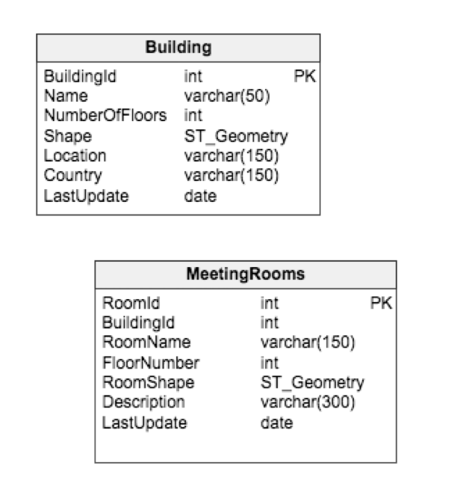

## User requirements

* The user needs to have IOS device.
* The user will require an Apple Appstore account to download the app.
* User needs to an active internet connection to use the application and will require to register, thus allowing user to login to the app and use all the features of the application.

## Environmental requirements

## Usability requirements

## Design and Architecture

Describe the design, system architecture and components used. Describe the main algorithms used in the project. (Note use standard mathematical notations if applicable).

An architecture diagram may be useful. In case of a distributed system, it may be useful to describe functions and/or data structures in each component separately.

## Implementation

Describe the main algorithms/classes/functions used in the code. Consider to show and explain interesting code snippets where appropriate.

## Graphical User Interface (GUI) Layout

Provide screenshots of key screens and explain.

## Testing

Describe any testing tools, test plans and test specifications used in the project

## Customer testing

Provide evidence for and results of customer testing. This may include ratings or quotes from the customer.

## Evaluation

How was the system evaluated and what are the results? In many cases this will include usage data and user feedback. It may also include performance evaluations, scalability, correctness, etc. depending on the focus of the project.

Quantative results may be reported in tables or figures. Note that tables have their caption above the table and need to be cross referenced in the text (see **Error! Reference source not found.**). In many cases, tables are better to read if you skip the vertical lines.

Table 1: Performance with and without caching

|  |  |  |  |  |  |
| --- | --- | --- | --- | --- | --- |
|  | **Nwithout** | **Nwith** | **Std.-Deviationwith** | **Std.-Deviationwithout** | **p** |
| Records | 100 | 200 | 2.54 | 3.97 | .002 |
| Data (GB) | 100 | 200 | 2.54 | 3.97 | .002 |
| Speed | 100 | 200 | 2.54 | 3.97 | .002 |

Figures have their caption below the figure as shown in **Error! Reference source not found.**. Make sure that if you use colour, the figure is still readable when printed in black & white, e.g., by using additional symbols, patterns, etc.



Figure 1: Learning gain across different experimental groups

# Conclusions

Describe the advantages/disadvantages, opportunities and limits of the project.

# Further development or research

I will perhaps come back to the project, as there is room for development on the idea. A more technical approach, something I was keen to avoid in order to meet practically and functional requirements early on, could be adopted to create a more interactive site. The website has the potential to follow many different paths. One path suggested to me was to design an e-learning site based on first aid, where users login over regular intervals to continually assess their first aid knowledge.

There is also room for the concept to grow into the mobile app world. A mobile app centring on the same basic concepts would involve designing an application offering first aid knowledge with ease. As my coding improves it is perhaps something I will consider.

# References

" SAP HANA XSJS Service". *Saphanatutorial.com*. N.p., 2016. Web. 4 Dec. 2016.

"Advantages of Using Swift". *Mlsdev.com*. N.p., 2016. Web. 1 Dec. 2016.

"Swiftyjson/Swiftyjson". *GitHub*. N.p., 2016. Web. 9 Dec. 2016.

# Appendix

## Project Proposal

### Objective

The objective of the project is to develop an iOS application, that allows its users to find, review and book meeting rooms. The user can search meeting rooms, upload images of the room which will be available on the app for other users for assistance, see where the meeting room is in the building on the map. The application will allow users ease of use and help quickly find info on their desired/selected meeting room like equipment available in that room etc., and additional information like which floor and my meetings tab which allows the users to see all his/her meetings and the app also allows the users to create meetings and save in the phone calendar.

**Map Feature**

Using Apple maps (MapKit) and the coordinates of buildings and meeting rooms. The building will be drawn on the map as a polygon and the meeting room as a point on the map along with the current location of the user.

**Camera Feature**

The users will be given an option to take photo through the app or choose an image from phone gallery and upload it to the application gallery.

**Gallery Feature**

A gallery of photos of the room and equipment available, the application will allow the user to upload images which will be available in gallery for other users to view.

**Review Feature**

This feature will allow the user to review the meeting room and the room ratings will be available for other users to see.

**Geo Location Feature**

The app will use geo-spatial data to display buildings and meeting rooms on the map and when a user is in a certain radius close to the meeting room. The user will receive notifications with approx. distance left from the meeting room.

And the functionality to disable this feature will also be given.

If the user has a meeting booked in a meeting room and if their phone is not within a certain radius to the meeting room, the user will receive a reminder notification. Also, the user will receive a reminder few minutes say 10 minutes before the meeting starts.

### Background

During my work placement at SAP SE, I was engaged in several meeting from my induction to my farewell meeting, there were more than 50 meetings, from team meetings to global team meetings, intern meetings and HR meetings, to employee farewell meetings which I was part of in the course of 7 months of internship.

And number one issue was finding the meeting room due to big size of the buildings, if the meeting room was close enough to my desk, it was easy enough to find the meeting room but the problem used to arise when the meeting rooms were on different floors, even different wing of the same floor and the problem was big when trying to find a meeting room on another building and some fancy names to the meeting rooms didn’t make much sense at all and the icing on the top if you are short on time i.e. have consecutive meetings to attend and the only solution available was to ask you collages if they didn’t know run towards the reception and they would show you a floor plan which sometimes didn’t made sense and overall experience in finding meeting rooms was not up to the standards to which it could be achieved.

I started some research and found other employees were facing the same issues and were just limited to using meeting rooms near their offices due the hassle of finding meeting rooms, after talking to people the user research findings were not just the interns who felt this pain, some of the very senior employees which were there for many years didn’t know where some of the meeting rooms were and since SAP is multinational company, there were always employees from different location which travelled to attend meetings and had very hard time finding the meeting room and first have to go to facilities department and the facilities member would manually assist wherever this process can be automated i.e. a simple to use application could solve this problem.

Hence, there is were the idea for the application is developed from but it is not just limited to corporate world the application can be put to use in universities and college with minor changes.

### Technical Approach

#### Mobile App / Client Application

The Client application, will be developed using apple’s new programming language : Swift 3 <https://developer.apple.com/swift/>



Reasons for Using Swift

Its fast, open-source, have to write less code and get more work done, its interactive and another motivation for using Swift for this project is, I have done some swift during internship and it’s a new language to me and I would like to learn it more in depth while working on this project.



and using Xcode 8 IDE <https://developer.apple.com/xcode/>



**XCODE**

**Xcode** is an integrated development environment (IDE) containing a suite of software development tools developed by Apple for developing software for macOS, iOS, WatchOS and tvOS.

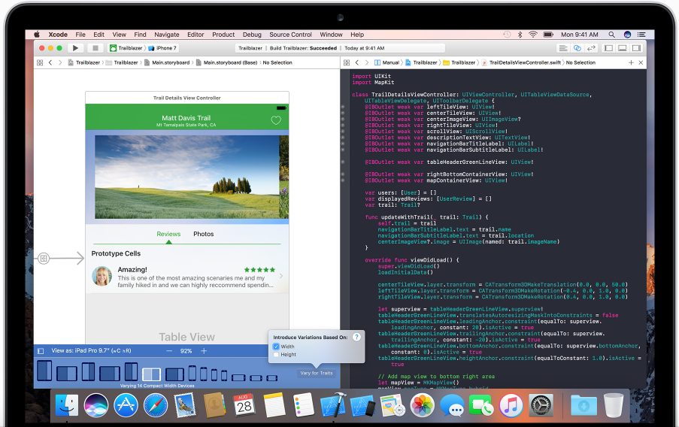

The mobile application will run on IOS devices including iPhone and iPads.

#### Backend

a JavaScript based Web service will be developed which will expose the data for the use of client app.

**On database side**: Geo-spatial features of MySQL/SAP Hana Spatial will be used.

**What is SAP Hana Spatial?**

Hana Spatial is a feature of SAP Hana

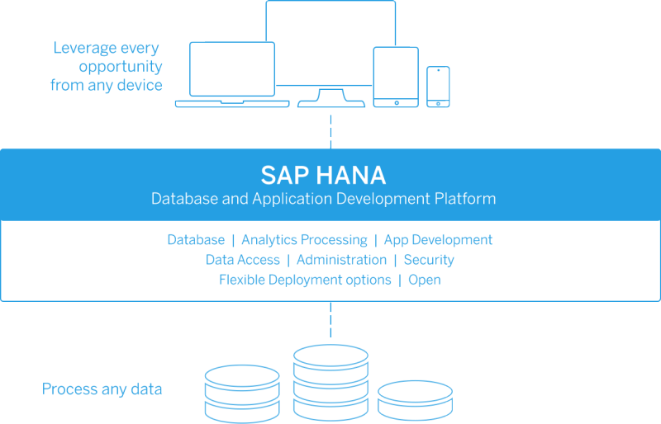

Why Hana Spatial?

HANA Spatial delivers the ability to store and process geospatial data types like ST_POINT, ST_GEOMETRY etc. Which allows to store co-ordinates for the buildings and meeting rooms for this project.

### Special resources required

This project doesn’t necessarily need any special resource, wherever the project can be taken to a different level by implementing beacons for indoor navigation or sensors to track presence of people in meeting rooms.

### Gantt Chart

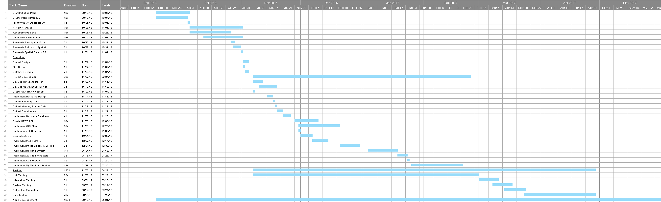

### Technical Details

Implementation languages and principle libraries:

**Frontend / Client Side:**

Swift 3 <https://developer.apple.com/swift/>

Core libraries:

* Foundation
* CoreLocation
* UIKit
* CoreLocation
* MapKit

And possibly some HTML and CSS.

3rd Party libraries

SwiftyJSON.swift <https://github.com/SwiftyJSON/SwiftyJSON>

**Server Side:**

SAP Hana Spatial database

JavaScript

MySQL

Possibly REST Architecture

### Evaluation

For Unit testing of Swift - XCTest Unit Testing framework.

For unit testing of Javascript – QUnit or Jasmine Javascript Testing Framework.

System Testing – will be performed on entire system in the context of Functional requirements and system requirements

Integration Testing – Continued research, no decision made on this at this time.

How will the system be evaluated by the end user?

* Discussion with College Staff, Corporate Organisations
* College students discussing the app and its features.
* By getting feedback on prototype.

### Proposed Supervisor

Cristina Muntean

## Project Plan

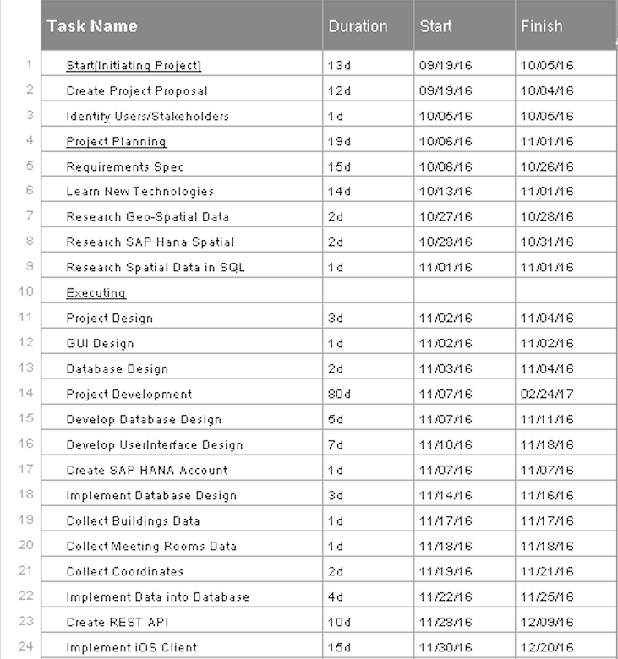

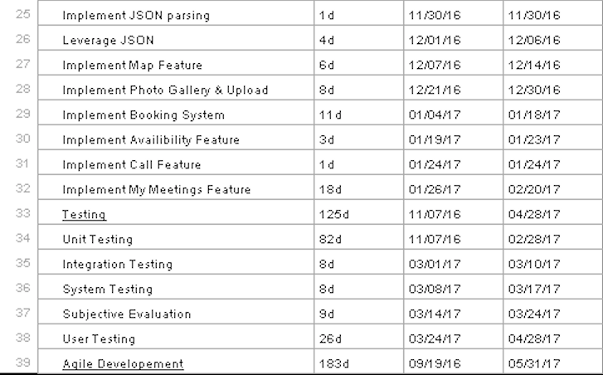

## Requirements Specifications

### Introduction

#### Purpose

The purpose of this document is to set out the requirements for the development of Meeting Room Pro project. The application assist users to find meeting rooms among multiple buildings in multiple locations, with ease of use and review rooms and find relevant information about the rooms.

The intended customers of the application are medium to big size corporate organisations with multiple buildings and hundreds of rooms. And educational institutions like universities and colleges. The target users of the application includes but not limited to – company employees (managers, team leads, interns), facilities department, It department and in educational institutes college staffs and students will be major target audience.

The intended audience for this document is myself, potential clients of the project and the academic staff at the National College of Ireland.

#### Project Scope

The scope of the project is to develop quality native IOS application allowing the users to use it on their iPads and iPhones. The application shall show the current location of user in a map view which will allow users to see how far they are from the meeting room, also user shall receive notifications, and the app shall also allow booking and availability feature and some other features. Which will attract users and potential client to get involved with the project also form my research I found no product similar to this application exist in the market. And, the project scope is more stronger due to the fact the application works out of the box (*application client can be easily used for any organisation without any prior changes or any dependencies. Only, different .csv files with building and meeting room information tailor the application for any organisation*).

I was involved in several discussions with Manuel Saez, my manager at SAP SE (internship) and my academic supervisor Christina Muntean. To elicit the following requirements

Here is a list of main features of the application:

* The app shall allow the user to book a meeting room while specifying the date and time of the meeting.
* The app should be able to read users device calendar and check if a meeting exists, the user receives a notification.
* The app shall be able to run smoothly on all iPhones and iPads.
* The app shall have responsive GUI / interface which allows the app to function properly and look good and function properly on different screen sizes.
* The system shall have a database in order to store building and meeting rooms information.
* The database shall have the capability to store geo-spatial data.
* The app must make a secure connection with backend the web service using authentication.
* The system shall have a web service to return data in either JSON/XML format, that will be displayed in the app.
* The application shall have a simple web based dashboard to allow the administrator to add more buildings and rooms with ease.
* The application shall be scalable.
* The application shall have Geo location feature so that when a user is within a certain radius of the meeting room or if outside building gets notified through a friendly notification. “Hey you are this close (*approx. location*) to your destination”.
* The application shall have a gallery to showcase photos of the room and an upload feature that allows the users to upload photos of a room which will also be available to other users to see and benefit from.
* The application shall have an expandable map with building drawn as a polygon and room as point and with apple maps most of the buildings have 3d view available which will allow the user to see the building in 3d view and find where the meeting room is located in the building.
* The application shall provide functionality to make a call from the app to key contacts of the meeting room like IT or Facilities department.

The application will be implemented using open-source programming language Swift 3 and Xcode Editor with continuous unit testing. And on the backend, SAP Hana Spatial and a JavaScript based web service.

#### Definitions, Acronyms, and Abbreviations

SAP SE – German Multinational Software Company.

NCI – National College of Ireland

SAP Hana – In memory, column oriented RDBMS.

RDBMS - Relational Database Management System.

Hana Spatial – feature of SAP Hana that allows us to store Geo-Spatial Data.

Geo Spatial Data – Data that has geographic positioning information.

GUI – Graphical User Interface

Shall - The term “*shall”* is used in this document to describe features which the system must have.

Should - The term “*should*” is used in this document to describe a feature which the system should have but may not.

Customer – The term “customer” is used in this document in context of potential users and clients.

### User Requirements Definition

The requirements that I have outlined in the project scope section of this document are that of the customer after D-Shop design thinking and several consultations with myself.

The most of user requirements for this project were collected/suggested by potential users during my internship in SAP SE and during the project idea presentation at SAP D-Shop innovation day on 17th and 18th August 2016 through design thinking (*heading 3*). And some were suggested my my manager at SAP SE and some by project supervisor at NCI.

MeetingRoom Pro will be an all-in-one room assistant application that will help users find meeting rooms, view them on map of building and also find relevant information like floor, room type, capacity, which building the room is located in, city, country and number of floors in that building.

The user will not have to register in order to access the app content. However, in order to review, book meeting rooms, and contribute towards gallery, the user will have to register.

Users will complete a standard registration in order to gain full access to the application features. Not only will registered users have access to content and features but will also have the permission to delete, moderate or upload content.

The users can have different account types –

* Guest *(unregistered)* – View Content Permission
* Basic User *(registered user)* – Review rooms and upload photos to gallery permission
* Moderator/Admin – Review, Upload and Delete content permissions

### Design Thinking for User Requirements Definition

Design thinking is a methodology used by designers like myself to solve complex problems and find desirable solutions for clients. Design thinking can help all sorts of organizations uncover new ways of thinking and doing things.

These are the design thinking process that were used during user requirements definition –

**Empathized with Users** – Observed, engaged and tried to understand user requirements.

Because as designer / developer problems we try to solve are rarely ours so we need to understand user first to develop an application for them.

**Defined the problem –** Brought clarity and focus to design space and framed the problem.

**Idea Generation** – Allowed the users to come up with idea, features and functionality they would like to see in the application. Through brain storming and putting ideas on white board.

### Requirements Specification

#### Functional requirements

Use Case Diagram System



The above Use Case Diagram provides an overview of all functional requirements of this project.

##### Requirement 1: Easy to Use GUI

###### User Story

As a user I want to have an easy to use interface so as I can navigate through the app easily with little time needed to be spent learning how to use the app

**Use Case Diagram**



###### Description & Priority

The system shall have an easy to use graphical user interface. Navigation will be possible through the touch screen functionality of the IOS device. The design shall also be responsive so as to support different screen sizes of iPhones and iPads.

*Essential and High Priority Requirement*.

###### Requirement Activation

This requirement will be activated upon starting of the application.

###### Technical Issues

GUI Need internet connection to get data from API which will be shown in the application, slow internet connection can affect performance of the GUI.

###### Risks

Provision must be taking that not all users have a good understanding of technology and the use of mobile platforms. If the GUI is to become too complex, some users may not use the application. This requirement is at the core to the success of the system.

###### Dependencies on other requirements

N/A

##### Requirement 2: List and Find(Search)

###### User Story

As a user I want to be able to find buildings and meeting rooms with ease. Like a clickable list of buildings which then browse to list of meeting rooms also search and I can select a meeting room and find it or use other features like room booking, gallery upload etc.

###### Description & Priority

The system shall allow to search and also provide list of available buildings and meeting rooms.

*High Priority*

###### Requirement Activation

The requirement to list buildings and meeting rooms will be activated upon starting of the application and search is activated when user enters in search bar.

###### Technical Issues

N/A

###### Risks

This requirement is at the core to the success of the system as most of the requirements hereafter have a dependency on this one.

###### Dependencies on other requirements

This requirement has a dependency on requirement 1 - Easy to use GUI.

##### Requirement 3: Map / Navigation

###### User Story

As a user I want to be able to view the building highlighted on the map. Also the meeting room I am looking for along with my current location and some information about the building and room like floor number.

###### Description & Priority

The system shall have an expandable map with current location of the user and building drawn on the map.

*Optional: The application should leverage some sensors or beacons implemented in the building for effective indoor navigation as GPS may not provide accurate location indoors.*

###### Requirement Activation

The requirement will be activated when the user selects a meeting room from a list of rooms.

###### Technical Issues

N/A

###### Risks

May face some issues with current location of the user while indoors as GPS is not designed for indoors and this may affect the accuracy of the location slightly.

###### Dependencies on other requirements

N/A

##### Requirement 4: Geo Location Notifications

###### User Story

As a user I want to have notifications automatically sent to me when within a certain radius of the building or the meeting room so I am notified that the destination is close enough.

###### Description & Priority

The system shall have functionality that when a user’s smart phone comes within a certain radius of the meeting room a notification will be sent to remind them with approx. distance to the destination i.e. *"Hey, you are “approx. distance” from your destination ….".* Functionality to unsubscribe to this service should also be provided. *High priority*.

###### Requirement Activation

This requirement will only be activated if a user brings their mobile device which they have the app installed on within a certain radius of the building/meeting room. This distance will be tweaked at the system/ user testing stage of project. This service should also only occur once while finding a meeting room as if a client user was moving in and out of the geographical perimeter they will not receive multiple notifications. As stated above functionality to unsubscribe to this service should also be provided.

###### Technical Issues

N/A

###### Risks

N/A

###### Dependencies on other requirements

N/A

##### Requirement 5: User Registration

###### User Story

As a user I shall be able to easily register within seconds to use the advanced features like posting reviews and uploading photos.

###### Description & Priority

The system shall provide a standard registration and login. The requirements like booking and reviewing require registration in order to allow users to use these features.

*High Priority*

###### Requirement Activation

The requirement is activated when user wishes to book, review meeting room and upload photos of the meeting room.

###### Technical Issues

N/A

###### Risks

N/A

###### Dependencies on other requirements

N/A

##### Requirement 6: Booking System

###### User Story

As a user I want to be able to book meeting rooms through my smartphone so as I can book meeting rooms easily from anywhere.

###### Description & Priority

Functionality for users to book meeting room once selected a meeting room. This feature shall have its own page and be easy to use i.e. drop down lists to choose data and time of booking and the user shall be able to see the booked meeting rooms.

*High priority*

###### Requirement Activation

This requirement will be activated if the client user wishes to book a meeting room.

###### Technical Issues

N/A

###### Risks

This requirement is very important as some of the requirements hereafter have a dependency on this one.

###### Dependencies on other requirements

This requirement has a dependency on requirement 1 - Easy to use GUI and Requirement 2 – List and Search

##### Requirement 7: Photo Gallery

###### User Story

As a user I shall be able to see some photos of the meeting room showing the equipment available and size of room straight from the app.

###### Description & Priority

The system shall have a photo gallery with multiple photos of the room.

*Medium Priority*

###### Requirement Activation

The requirement will be activated when a user selects a meeting room from the list.

###### Technical Issues

N/A

###### Risks

N/A

###### Dependencies on other requirements

N/A

##### Requirement 8: Photo Upload

###### User Story

As a user I shall be able to upload some picture from my phone gallery or camera if some pictures are missing in the Gallery.

###### Description & Priority

The system shall allow all registered users to upload images of the rooms to the photo gallery. And also allows users with admins and moderator accounts to delete the low quality images straight from the app.

*High Priority*

###### Requirement Activation

The requirement will be activated when user wishes to upload an image.

###### Technical Issues

N/A

###### Risks

Some users may try to spam or misuse this feature.

###### Dependencies on other requirements

The requirement has a dependency on requirement 7: Photo Gallery

##### Requirement 9: Review

###### User Story

As a user I would like to see some reviews available about the room and its equipment and also like the functionality to review it myself.

###### Description & Priority

The system shall allow the registered users to review meeting rooms based on different parameters like – functionality and quality of available equipment, if the room temperature was good and so on as user feedback will help improve the quality of the meeting rooms and the meeting rooms getting low ratings can be improved and get more attention from IT and Facilities department.

*Medium Priority*

###### Requirement Activation

The requirement will be activated when the user wishes to review meeting room.

###### Technical Issues

N/A

###### Risks

N/A

###### Dependencies on other requirements

N/A

##### Requirement 10: My Meetings

(Calendar event / Reminder of booked meeting feature)

###### User Story

As a user I would like to see all my meetings and simply start the map navigation.

###### Description & Priority

The system shall provide a list of meetings booked for the user and the user will receive a reminder notification. The system should be able write and read meetings to and from the device calendar.

###### Requirement Activation

The requirement will be activated when the user has some meetings in their calendar.

Medium to Low Priority

###### Technical Issues

N/A

###### Risks

N/A

###### Dependencies on other requirements

The requirement has dependency on requirement 6: Booking System

##### Requirement 11: Call

###### User Story

As a user if I am in a meeting and some equipment is not working I should be able to contact the key contacts for the room that can fix the problem for me i.e. make a quick call from the app.

###### Description & Priority

The system shall provide contact information for key contacts and allow user to make a call.

###### Requirement Activation

The requirement is activated if the users wishes to make a call through there phone.

###### Technical Issues

N/A

###### Risks

N/A

###### Dependencies on other requirements

Requires a sim card to make calls via the phone.

#### Non-Functional Requirements

##### Scalability requirement

###### User Story

N/A

###### Description and Priority

With regards to the intended number of users in big and medium cooperate organisation with thousands of employees and teachers and students in educational institutes and the projected load scenarios, the intention is for the system to be able to serve queries in thousands/ day (in large part during the 9-5 peak traffic hours) and the application shall also be scalable to use for any organisation with little to no changes to the app’s code.

*High Priority*

##### Availability requirement

###### User Story

As a user I want to be able to access the app at any time I wish.

###### Description and Priority

The app shall be accessible at any time of the day on any day of the year. *High priority*.

##### Physical requirement

###### User Story

As a user I want to be able to access the app from anywhere.

###### Description and Priority

The app shall work on mobile devices. *High priority*.

##### Security and Privacy requirement

###### User Story

As a user I want the app to be secure like my password must be safe.

###### Description and Priority

The app shall achieve security through encryption and SSL certificate when connecting to the server. *High priority*

##### Reliability requirement

###### User Story

As a user I want to the app to be reliable.

###### Description and Priority

The app shall be reliable i.e. stable and consistent of what is expected out of it. *High priority*.

##### Maintainability requirement

###### User Story

N/A

###### Description and Priority

The app shall be easy to maintain on daily basics, and it should be easy to fix bugs, add new features, increase performance and easier for others to maintain the software.

*High Priority*

### Interface requirements

#### GUI

The app will run on IOS devices that use touch screen functionality. Below is a quick mock up of the GUI for showing how the user will interact with it. Displaying an easy to use interface. *Note: These mock ups can be seen abstractions of what will be finally implemented.*

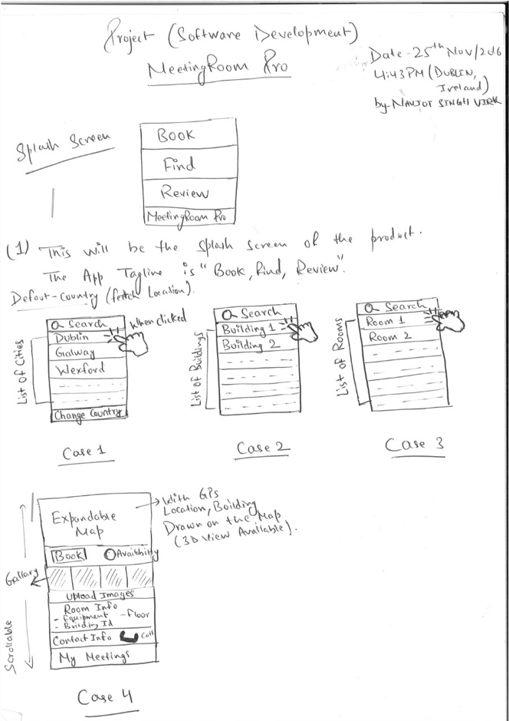

**GUI for the Application**

On starting the application, the user will see Case 1 – List of Countries and Search

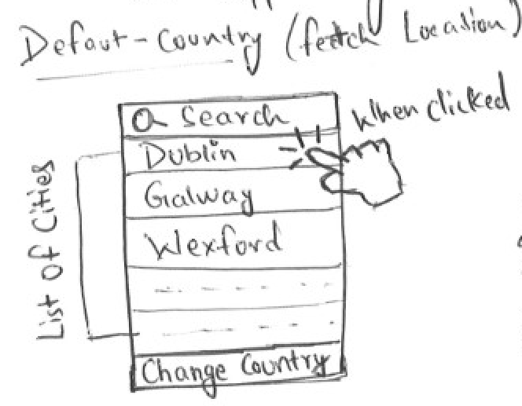

On Click - > Case 2 – List of Buildings and Search

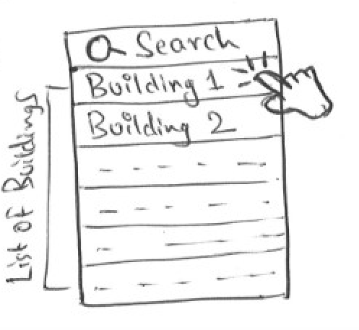

On Click - > Case 3 – List of Meeting Rooms and Search

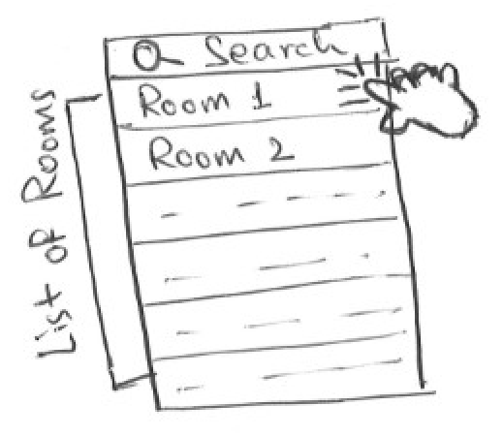

On Click -> Case 4 -> All info about selected meeting room, navigation, map, notifications, room booking system, availability, photo gallery, photo upload, call option and Meeting Rooms

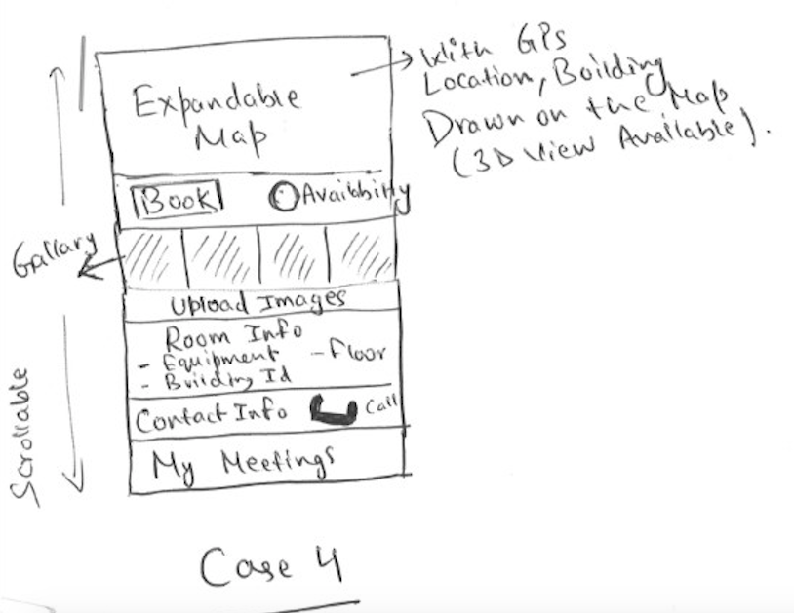

*Note: Please note Case 4 may be broken into further cases when the actual application is developed.*

#### Application Programming Interfaces (API)

The following is a list of device APIs which the system will implement:

* Apple MapKit
* Apple CoreLocation
* Apple Foundation
* Apple UIKit
* Apple XCTest
* SwiftyJSON (3rd Party)

#### Database

The system will interface with a database that stores information about buildings, meeting rooms, users, bookings and photo gallery.

Relational database tables for the following list will be developed:

* Buildings
* Meeting Rooms
* Users
* Bookings
* Reviews
* Photo Gallery

### System Architecture

I have settled on the particular system architecture as to create a consistent and fully functional system. The idea being to create architecture with potential for growth, yet for the system to be fully functional and operative from the beginning.

Users will have the initial option to register or not with the application. With registered users having the opportunity to upload photos, review rooms and book rooms.

On the middle tier will be the Presentation layer containing a REST API, a Business logic layer and a Data access layer(DAL). Finally, the Data layer which will be a SAP Hana database.

This architecture will be keeping with good practice maintaining good "separation of concerns " allowing for a loosely coupled system which will be easy to maintain and scalable if needs arise.

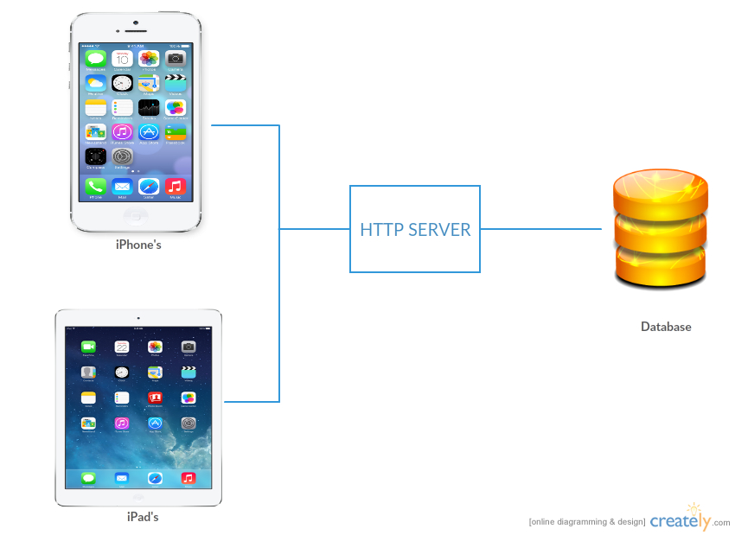

### System Evolution

The system can be extended over time as new technologies are introduced. Like aspects of indoor navigation can be brought to the project. The displayed content on the app will continually change, allowing for evolution within the application.

After the app has been in use for a period of time and if successful it may be possible to perform analytics on some of the data been gathered and stored by the app which may be of some benefit to the business. This will be looked at in further detail at a point in the future.

## Monthly Journals

### Reflective Journal 1

**Student name:** Navjot Singh Virk, x13112406

**Degree:** BSc. Honors in Computing (Software Development)

**Month:** September 2016

**Type:** Weekly Basis

#### Introduction

My name is Navjot Singh, 21 years old, passionate about technology, research and sports, finished my 7 months’ work placement with SAP SE in August 2016 to get back to college to finish 4th year of BSc honors in Computing in my chosen stream Software Development at National College of Ireland. At, SAP I worked with different projects with focus on iOS development using Swift which I love now. I feel satisfied while coding in general but love Java and Swift the most and enjoy making software, websites and mobile application both iOS and Android in my free time. Alongside, college I do freelancing since first year of college which provides me with real world experience and help me support my financials and college tuition and expenses. Currently, I am working with a client in Dublin on a marketplace website project.

Computing is my first love but I enjoy other things too like I love to read emotions in people and learn about human psychology, communication skills and some business and marketing as well which connects me to my roots which is my family business where I used to help my Dad while back home in school years.

I feel very confident to start my 4th year with the support of teachers and fellow classmates and friends and want to perform the best of me as in this last year I want to get better each and every day in every aspect of my life studies, gym, table tennis as these college­­ years won’t come back and I want to create memories here at National College of Ireland.

And I am absolutely delighted about starting the Software Project and would love to create a lovely piece of software that could be useful to people and make my well-wishers proud.

#### First month 19th Sept to 7th October

Attended first class on 19th of September with joy of finishing 3rd year and realising 3 years has gone fast and this final year is the one that need the most attention and I have decided to dedicate few hours each day to my studies and some extra hours on weekends and focus on the project continuously and try to work on project with an agile approach which I followed during my work placement.

**Week 1 (19th to 23rd)**

Attended first class from Eamon and received good tips and notes to get us started and Eamon explained us how things with work for this semester and a brief overview of 4th year project after class reconnected with classmates and went to library to research on an idea I was thinking could be a good software project for my 4th year project and also looking for alternate ideas as well just having my options open.

Continued the research for on the idea and to decide which programming language, tools and technology to use to get best out of my skills and also ensuring the project, I select/work on should stand out and push me out of my comfort zone to get results that I wish to get in my final year project.

Read the past year project reports available on Moodle and information on plagiarism and time management for good results.

Received the Project Pitch schedule were in the 3rd week all students had to present their idea in front of a panel of teacher without any props like presentation files, wireframes etc. Which was a little breath taking for some of us?

Overall, I believe first week was a good eye opener on what challenges to aspect in later weeks.

**Week 2 (26th to 30th)**

Monday, continued the research and discussed my ideas with Eamon and asked questions to clarify my doubts on What Eamon and other teachers will be expecting from us during the project pitch and on Thursday decided to go ahead with an idea that I researched about in my work placement and uploaded the Presentation file for the project pitch next which other lecturers would see to look if my idea had a potential to be developed further.

This week has been though since making a choice out of 100’s of ideas floating in your mind has never been an easy task for me and I believe almost everyone in the class felt the same emotion.

**Week 3 (3rd to 7th October)**

Monday started with a lot of questions asked in class and Eamon answered them all which I feel was helpful plus Eamon also delivered a little harsh speech to motivate the students to going to find an idea if they haven’t already.

And Wednesday 5th Oct, at 4:10 pm this was the time for my project pitch went 15 mins early outside the room to ensure I would be calm and collect during the project pitch. Exactly at 4:10 pm, Paul Stynes the chairperson for my project pitch came to call me for the pitch was a tough moment because know I had to present the idea I had been researching all this time and I have to deliver.

Started my Project Pitch,

My Project idea is to Create an iOS application for finding meeting rooms and people in a organisation or an educational institute, I have chosen this idea as I believe the idea has a good commercial implication as I when I was doing my work placement at SAP SE, I myself struggled finding meeting rooms at times and also found later other people were facing the same problem as well even employees that have been there for years would not know the meeting rooms and people in other SAP building and sometimes on different floors of the same building.

#### My Achievements

This month had been a good productive month can’t wait to know if the panel will approve my idea or ask me for some improvements as they suggested during the project pitch.

Overall, a good month. Worked well and would like to continue to work the same way and but would like to work even harder next month plus also send more time in library to research and work on the project.

#### Supervisor Meetings

We haven’t been assigned a supervisor yet but during this month I had a lot of chats with Eamon regarding project and asked questions and cleared my doubts.

I have presented my project idea to the panel of teachers.

Mr. Paul Stynes (Chairperson)

Mr. Ralf Bierig (Judge 2)

Mr. Eugene McLaughlin (Judge 3)

Date of Meeting: Wednesday, 5th Sept 2016 at 4:10 pm

Items discussed: Project Idea

Action Items: Waiting for approval on project idea.

### Reflective Journal 2

**Student name:** Navjot Singh Virk, x13112406

**Degree:** BSc. Honors in Computing (Software Development)

**Month:** October 2016

**Type:** Weekly Basis

#### Introduction

Last month every student presented their ideas to a panel of teachers and this document will provide a summary of the tasks and progress I made on weekly basis in second month after the completion of first month for my software project.

**Week 4 (10th Oct - 14th Oct)**

First few days of the week went nail biting waiting for the project pitch results. Then, our teacher Eamon announced the results in class which students got their project idea approved and which were not luck enough and had to select from teachers proposed ideas.

And luckily, the panel – Mr. Paul Stynes (Chairperson), Mr. Ralf Bierig (Judge 2)

Mr. Eugene McLaughlin (Judge 3)

Approved my project idea with 3 Yes ticks from all 3 teachers and I felt very confident and happy about it, I felt teachers appreciated my idea and know its my responsibility towards them that I deliver well and prove myself that the idea I proposed can be developed and will help people solve daily problems of finding rooms through my iOS application – Room Assistant.

And towards, the end of the week I started the project proposal document.

**Week 5 (17th Oct - 21st Oct)**

On Monday, worked on Project proposal and created a Github repo for the project, for source control.

Github repository: <https://github.com/Virksaabnavjot/RoomAssistant>

But sadly by Tuesday, I felt sick and went to saw a doctor and was recommended a weeks rest and could not work on the proposal or attend college for the rest of the week.

**Project proposal submission on Friday (I submitted what I finished before getting sick and informed my teacher Eamon Nolan).**

**Week 6 (24th Oct - 28th Oct)**

Felt a little healthy and again started working and completed the things that were left to finish in the project proposal.

By Wednesday, I started Requirements Specification Document and worked on it rest of the week.

And during this week, I was assigned a supervisor.

My supervisor: Cristina Hava Muntean

**Week 7 (31st Oct - 4th Nov)**

**Reading Week**

Reading week is the week I love since first year, it allows to catch up if left behind in any module and prepare for the upcoming tests and assignments.

Since, we have major CA test coming up for Web Services and API’s when back to college after reading week, like most of the students have been studying for the test and also continued dedicating some time each day to requirements specification document and some research on the project.

#### My Achievements

This month was good, recovered from bad health and completed a lot of work.

Finished the Project proposal, working on requirements specifications document and also worked hard in other modules and submitted a chess project feeling very motivated good progress happy with myself the way I am going and hope to go the same positive path for the rest of the year.

#### Supervisor Meeting

I have contacted my supervisor and the first meeting is due on 10 November.

Supervisor: Cristina Hava Muntean

### Reflective Journal 3 (November)

**Student name:** Navjot Singh Virk, x13112406

**Degree:** BSc. Honors in Computing (Software Development)

**Month:** November 2016

**Type:** Monthly Basis

#### Introduction

Last month was good and project proposal was completed and I was working on requirements specification document.

#### My Achievements

This month, I have finished the requirements specification document and stepped a SAP Hana Trail account, finished the database design and implemented it in the database, implemented a JavaScript service that returns JSON which our client uses to display information and provide functionality in the app.

With suggestions from my supervisor made some changes to project proposal document and requirements spec document to add few more feature which I will be working on next semester.

Implement the application in Swift 3 using Xcode and implemented features like list view to show buildings and meeting rooms and a map using Mapkit to display building as a polygon and meeting room as a point on the map and display current location of the user using CoreLocation.

Also, working on the Technical report about 70% finished and getting the project ready for mid term presentation.

#### My Reflection

Absolutely delighted with this month and a lot of functionality was implemented this month and some big documents like tech report are almost done. So, I feel proud about this month the only thing that didn’t go smooth in the beginning was parsing JSON in Swift but luckily found an open source library to take care of that effectively.

#### Intended Changes

Finish Technical Report and Keep updating project documents to achieve highest possible quality.

#### Supervisor Meeting

Supervisor: Cristina Hava Muntean

Supervisor meetings this month were very productive Cristina asked a couple of questions about the project and suggested improvements and provided with good advice on how to manage time and get better results and develop a high quality application.